



**IS480 Project Proposal**

**Dynamic Web Application**

**To Provide Project Management Insights**

**INSIGHTIERS**

**Version 3.0**

**18 October 2014**

|  |
| --- |
|  |

**Team Members:**

* Elaine Ng Yee Leng (elaine.ng.2012@sis.smu.edu.sg) – Project Manager
* Li Dan (danli.2012@sis.smu.edu.sg) – Lead Designer
* Liu Yining (yining.liu.2012 @sis.smu.edu.sg) – System Architect
* Zhang Annan (annan.zhang.2012@sis.smu.edu.sg) – Business Analyst
* Zheng Yixi (yixi.zheng.2012@sis.smu.edu.sg) – Lead Developer

**Faculty Supervisor:**

* Requesting for Prof Benjamin Gan, or Prof Richard Davis, or Prof David Lo

**Sponsor and/or Clients (if any):**

* Edmund Gair – Co-founder of Viatick
* Email address: [edmund.gair@gmail.com](mailto:edmund.gair@gmail.com)
* Website: <http://viatick.com/>

**Project Overview**

**1.1 Project Description:**

The aim of this project is to develop a web application that will provide business insights for Viatick’s project managers. This application will give the project managers a bird’s eye view of all the vital and useful information, such as the progresses of ongoing projects, number of developers Viatick has for each skill set and the average number of new projects Viatick takes on every month. This application will allow project managers to understand the workload the company has on hand and determine if they have sufficient resources to take on a new project, by introducing a simulation feature for project managers to simulate the estimated capacity[1] Viatick will be running on during the simulated period. On top of that, we will integrate a third party web-based project management application, Trello, into our application, which will allow project managers to manage their projects. We will also incorporate various modules, such as quotation and change request form, to further aid Viatick in managing their project documentations.

**1.2 Motivation:**

Currently, Viatick is using Trello to record all projects. However, the overall project timeline and breakdown of the project tasks are not included in Trello and project managers have to keep track of project timeline by manually creating it in an excel spreadsheet. More often than not, project managers would have to spend a large amount of time going through each project Excel spreadsheet to determine if they have sufficient hardware resources and developers to take on a new project. Since Trello does not provide PMs with the necessary business intelligence to make informed decisions such as selecting the most appropriate date to kick off a new project, managing projects becomes extremely inefficient and time consuming. There is clearly a lack of proper visualization tools which can provide business intelligence for project managers to get an overall idea of the workload that Viatick is currently handling or could be potentially handling in a specific period of time. This is where our team wishes to step in and address the frustrations project managers face in monitoring all ongoing projects and managing the company’s resources well.

**1.3 Stakeholders:**

|  |  |
| --- | --- |
| Sponsor | Mr. Edmund Gair, co-founder of Viatick.  Edmund is a SMU alumnus and currently a co-founder of Viatick |
| Client | The web application will be used by Viatick’s staffs, as well as their business clients who will have access to certain modules for viewing purposes. |

**1.4 Deliverables:**

A web application will be deployed. Project managers will be able to create projects and tasks in both Trello and our application and monitor the progresses of the projects. They can also create pseudo project in the simulation page. Clients will be able to view certain modules, such as the quotation and contract modules and download them for documentation purposes.

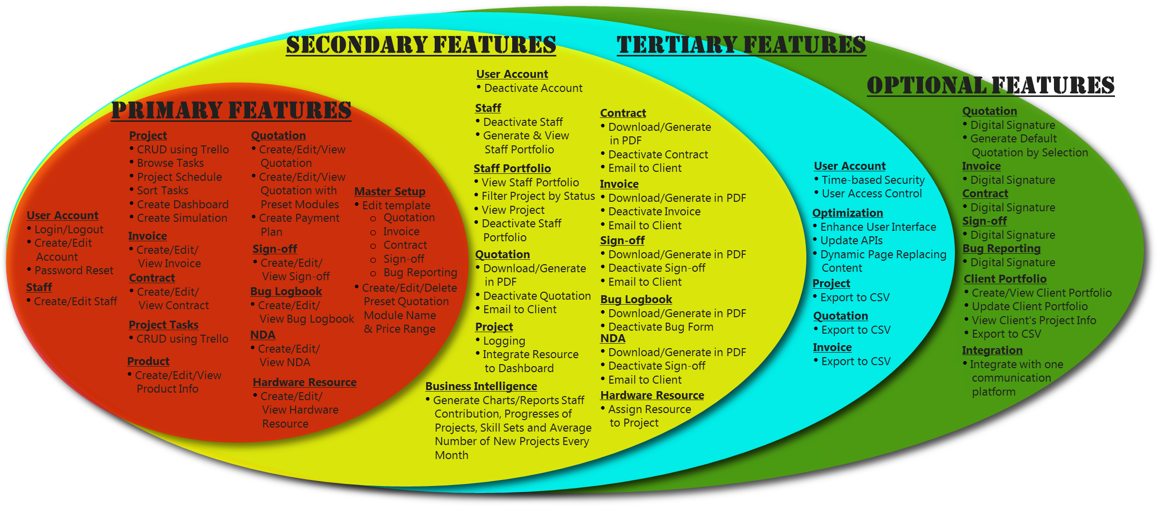**1.5 Scope:**

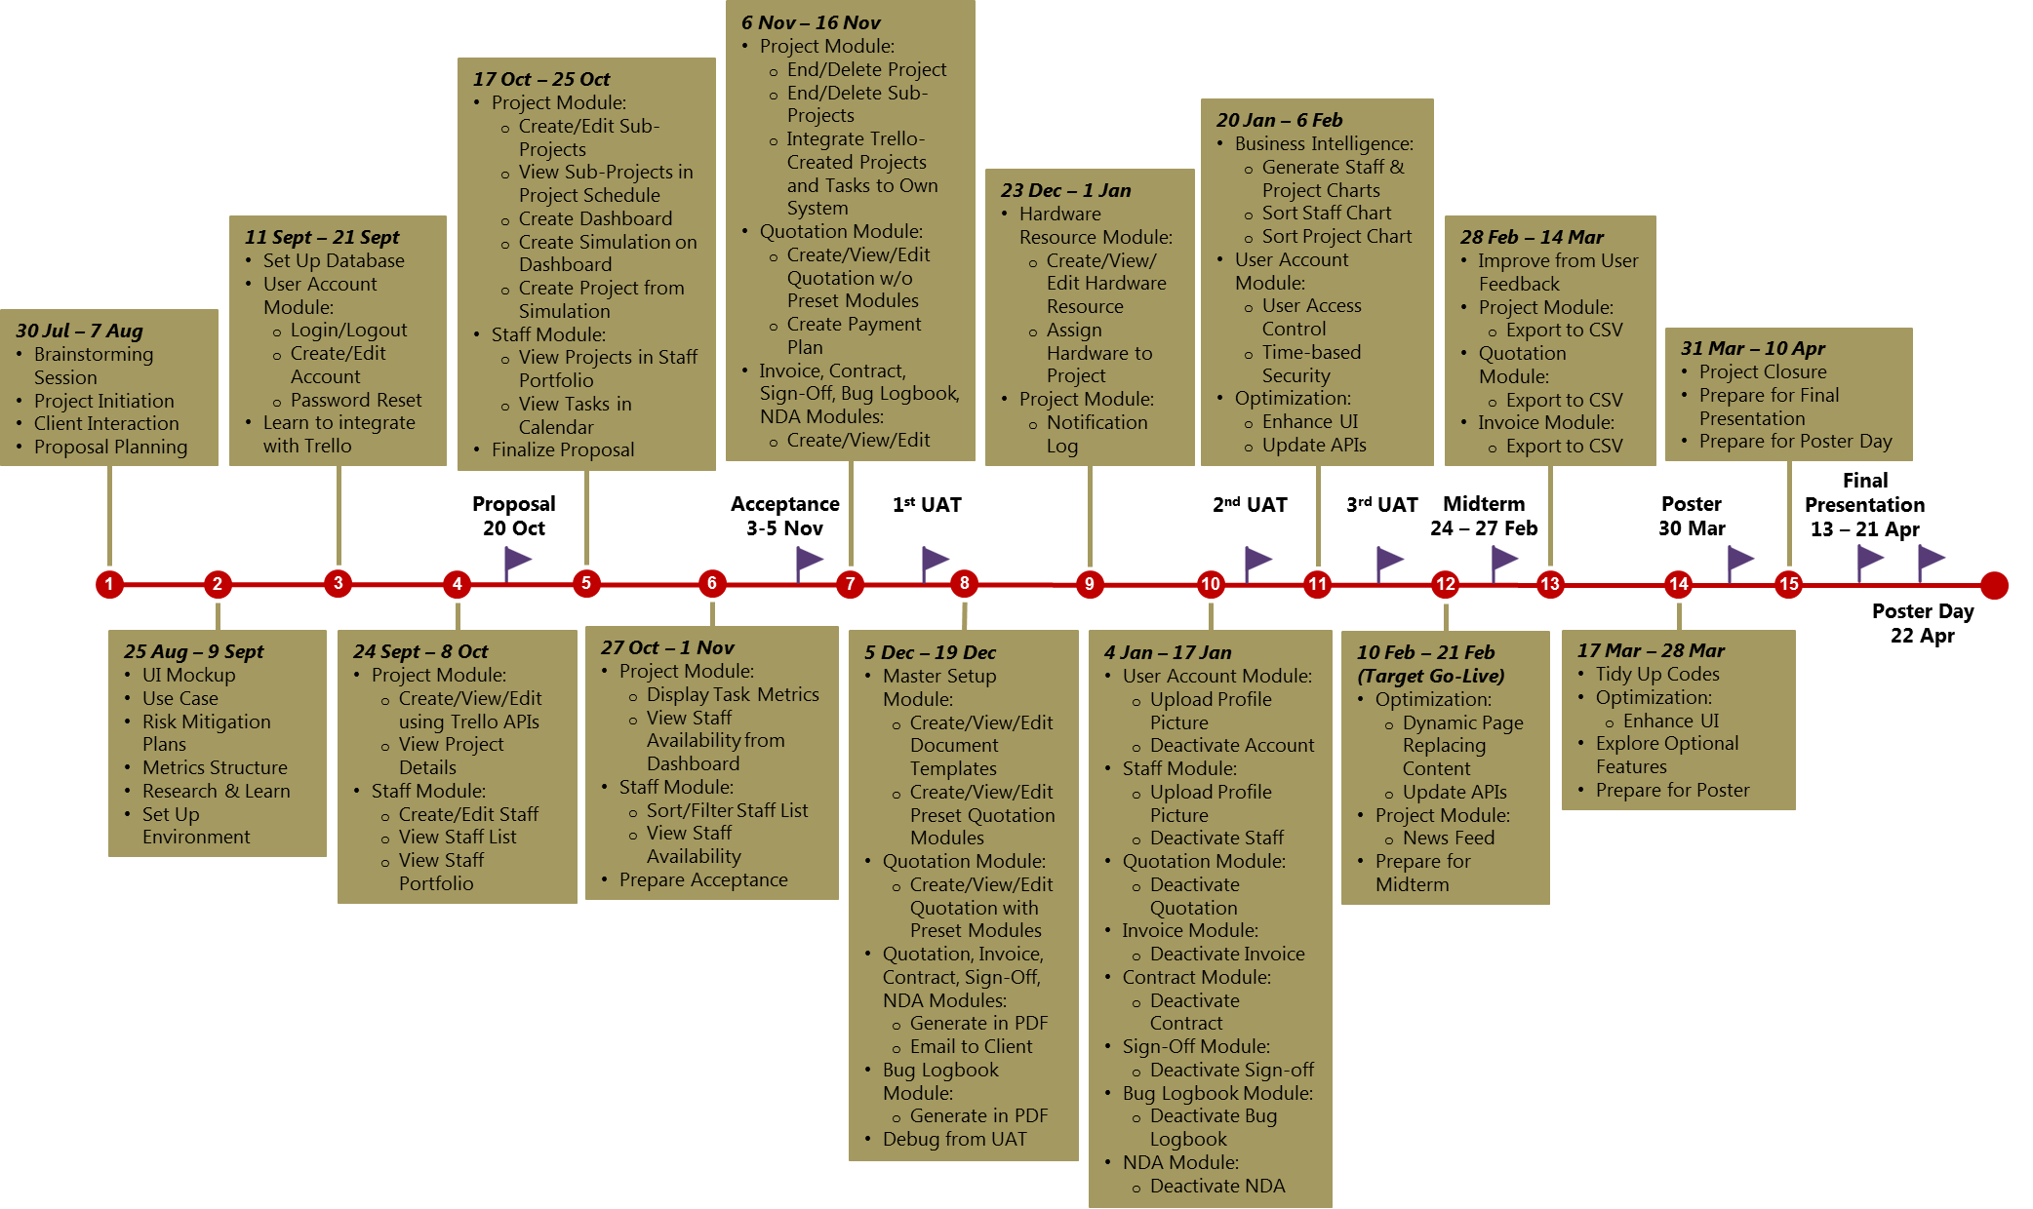**Project Timeline:**

**Project Plan**

**2.1 Risks:**

Exploring a third party web application may be more challenging than expected. Misinterpretation of project requirements is also a potential risk, since there are many requirements that we need to take into consideration.

**2.2 Resource and Reference:**

A staging server will be provided by the client. Technologies and resources to be used include HTML 5.0, Eclipse, Java, Javascript, CSS 3.0, MySQL, JQuery library, Twitter Bootstrap, Tortoise SVN and Trello APIs.

1. By capacity, we are referring to the number of ongoing projects, number of projects that are going to be due, and the number of go-live projects that are still under warranty Viatick will be having during a period of time.